*Florida International University*

*School of Computing and Information Sciences*

Software Engineering Focus

Feature Document

User Story ID #653

**Name:** Kyle Ryan

**Team Member(s):** Mario Fidalgo

**Project:** Mobile Judge 9.0

**Product Owner(s)**: Masoud Sadjadi

**Mentor(s)**: Masoud Sadjadi

**Instructor**: Masoud Sadjadi

**User Story Name: Add Downloadable Template for Judges**

* Description: As an Admin, I would like to be able to download a sample file to fill out so that I can easily upload it back to the system.

Acceptance Criteria

* The file I download should be in CSV format.
* The CSV should contain Name, Email, Title, Affiliation.

**Use Case**

* Name: Add downloadable template for Judges
* Actor: Admin
* Preconditions: User must be logged in as an admin and in the people view then Judges tab.
* Description <Flow of events>:

1. User selects the “Download Template” button

2. System creates a CSV of a template that can be imported at a later date and prompts user to download.

3. User selects location to save file.

**Use Case Diagram**

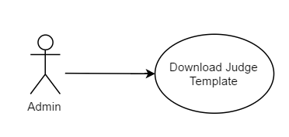

**Sequence Diagram**

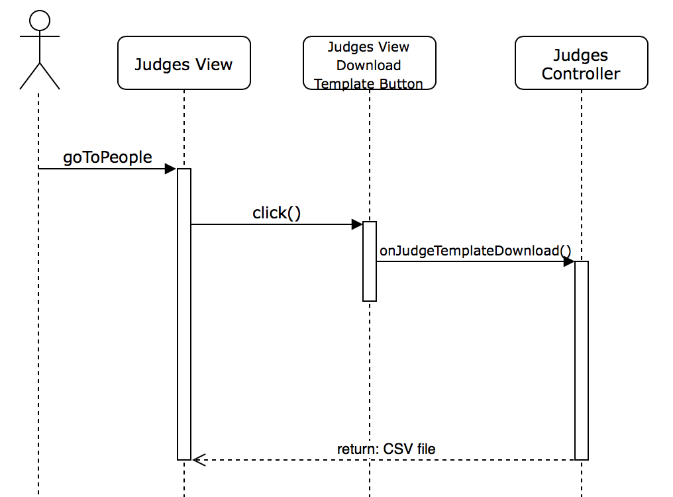

**Class Diagram**

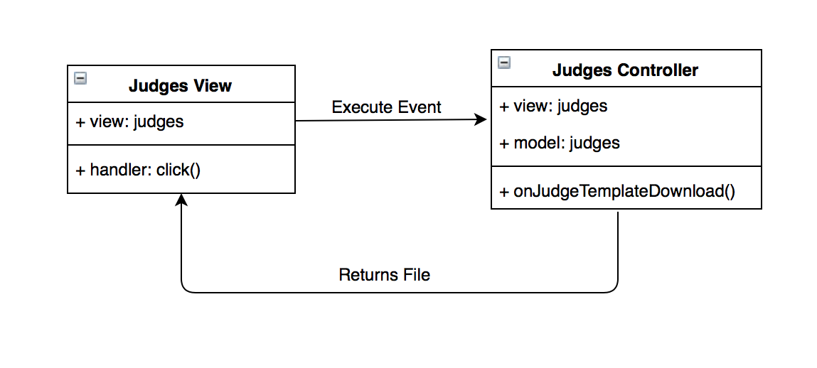

**Unit Test & Integration Test**

**Test case ID:** MJ-653-01

**Description/Summary of Test:** Download Judge’s Import Template

**Precondition:** Admin is logged in and currently viewing the judges tab found in people side tab.

**Expected Results:** Popup requesting Admin to save or open CSV file of a Judge Import Template.

**Actual Result:** A popup displayed once Download Template was clicked, and the file contained a template to fill out and be used when importing judges to Mobile Judge.

**Status (Fail/Pass):** Pass

**Visual User Guide**

